PRACTICAL SUBMISSION RECORD- A.Y. 2025-26

Class: SYMCA Div.: B  Semester: III | Course Code: MCA10602  Course Name: Laboratory Practice III |  | Batch: S2
Name: Ajit Bajarang Mali |  | Roll No: 52140
CO No: CO607.2 |  | Assignment No: 03

Title:- Install Selenium IDE in Mozilla Firefox/Google Chrome Test following scenario in Selenium IDE using record and replay Invoke Google Chrome browser
- Open URL: www.google.com
- Click on the Google Search text box.
- Type the value "java tutorials"
- Click on any of java tutorial link

Step 1: Starting the Project in Selenium IDE
This image shows the initial welcome screen of the Selenium IDE application.
- Topic: Opening Selenium IDE and Starting a New Project
- Step: Select "Record a new test in a new project" from the "Welcome to Selenium IDE" dialog box to begin the recording process for the test scenario.
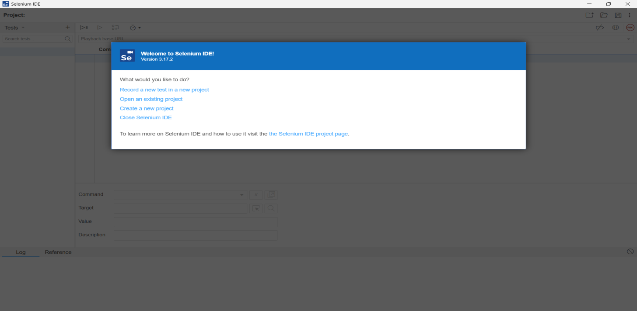

Step 2: Setting the Base URL and Beginning Recording
This image shows the prompt to set the project's base URL and the confirmation of the recording status, along with the starting page in the browser.

Topic: Defining the Base URL and Initiating Recording
- Step 1: Enter the Base URL for the project, which is the starting point of the test (e.g., https://www.google.com/).
- Step 2: Click "START RECORDING" to launch the browser and begin tracking user actions.
- Step 3: The browser opens to the specified Google URL, and a banner confirms that "Selenium IDE is recording. ".
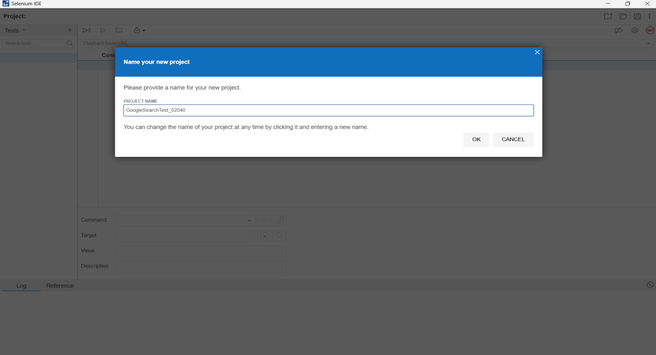

Step 3: Performing the Search Action
This image captures the search action: typing "java tutorials" into the Google search box and the subsequent display of search results.

Topic: Executing the Test Scenario Actions (Search and Navigation)
- Step 1: In the browser, the user types the value "java tutorials" into the Google search box.
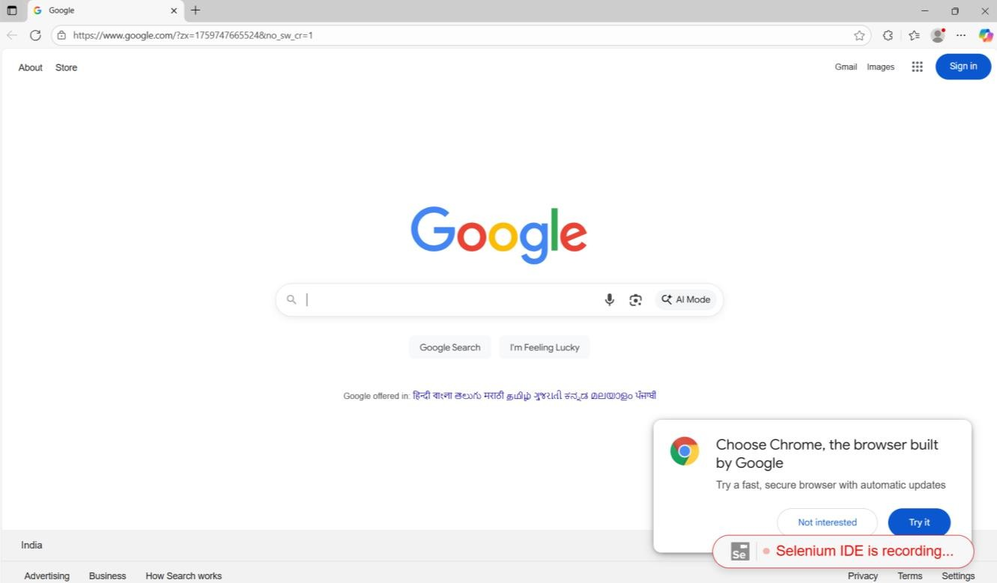
- Step 2: Google displays a list of search results for the query "java tutorials".
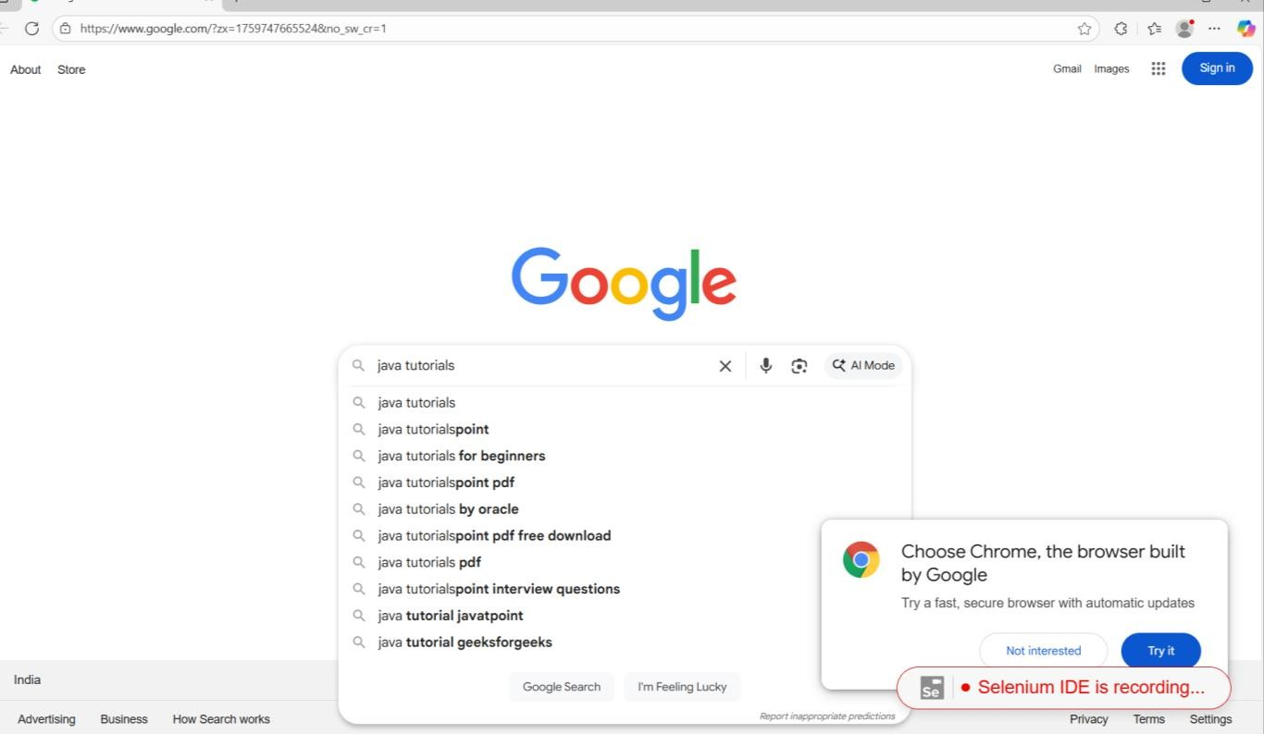

- Step 3: The user clicks on one of the search results, such as the "Java Tutorial" link from W3Schools.

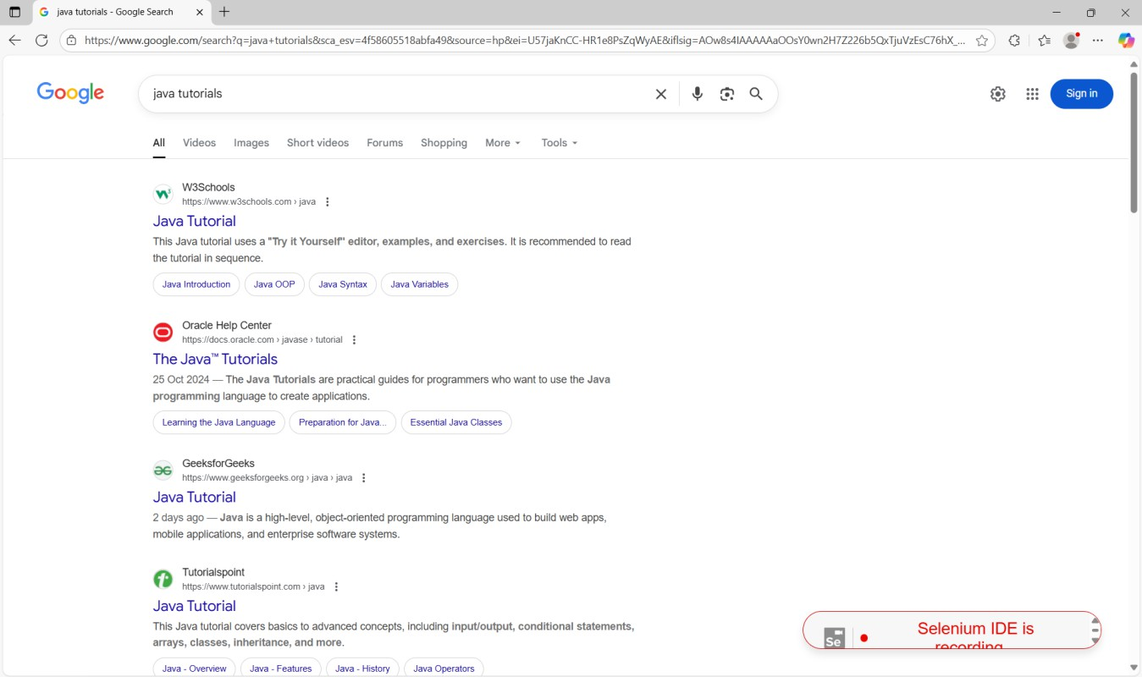

- Step 4: The recording status, "Selenium IDE is recording. ", remains active throughout these steps
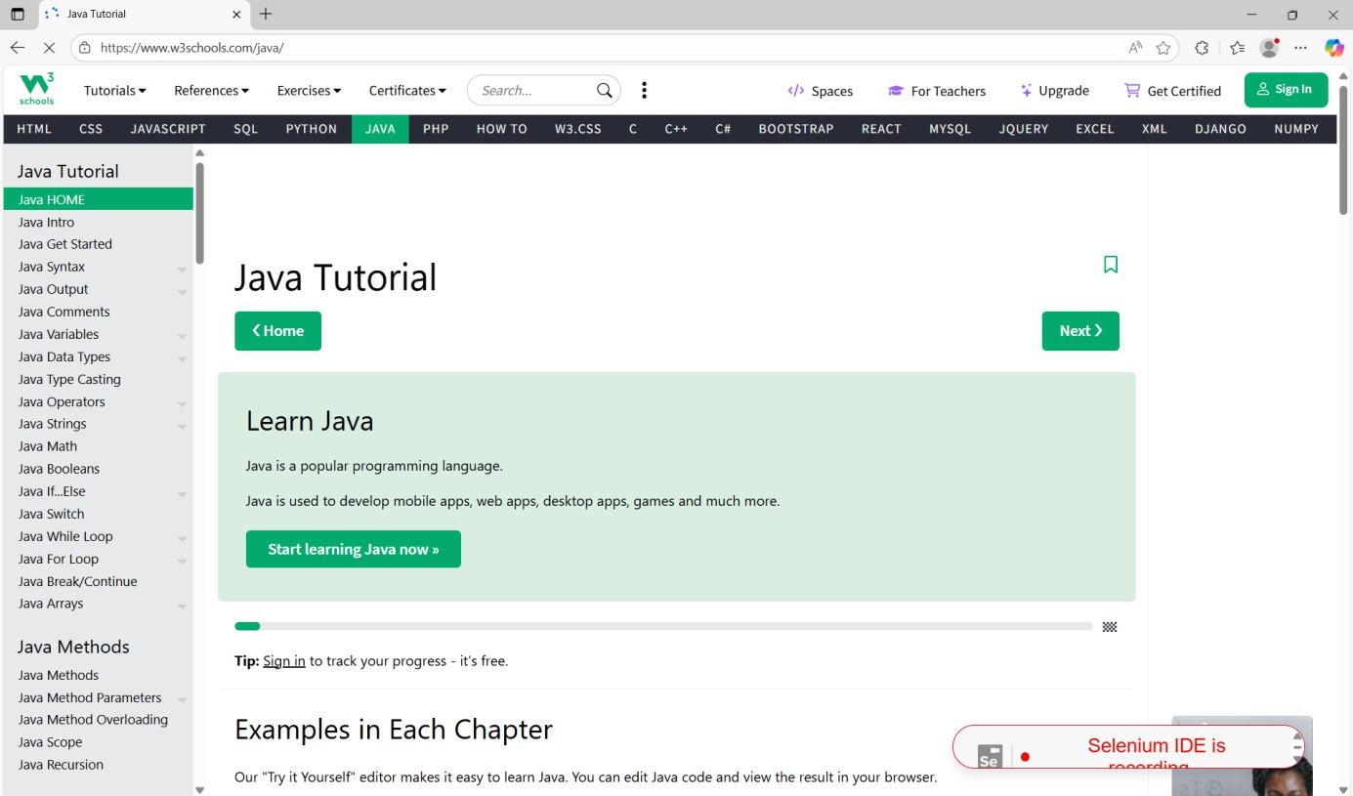

Photo 4: Viewing the Recorded Commands (Part 1)

This image shows the first part of the recorded test script within the Selenium IDE window after the recording has been stopped, including navigation to the tutorial page.

Topic: Test Script Generation and Verification (Commands View)
- Step 1: The recorded actions are displayed as a list of Commands in the Selenium IDE interface.
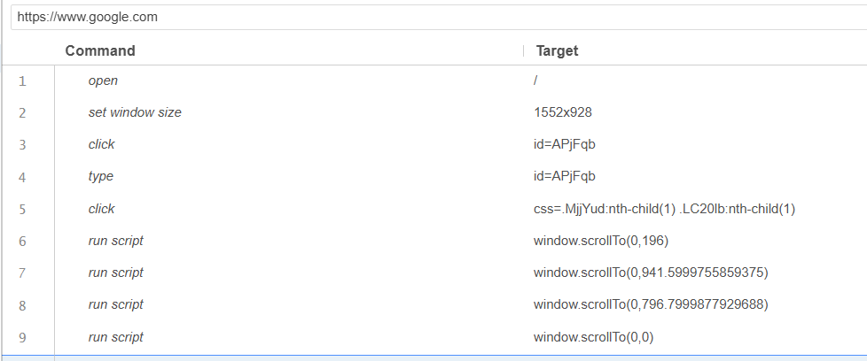

Step 2: The test is now on the "Java Tutorial" page from W3Schools.
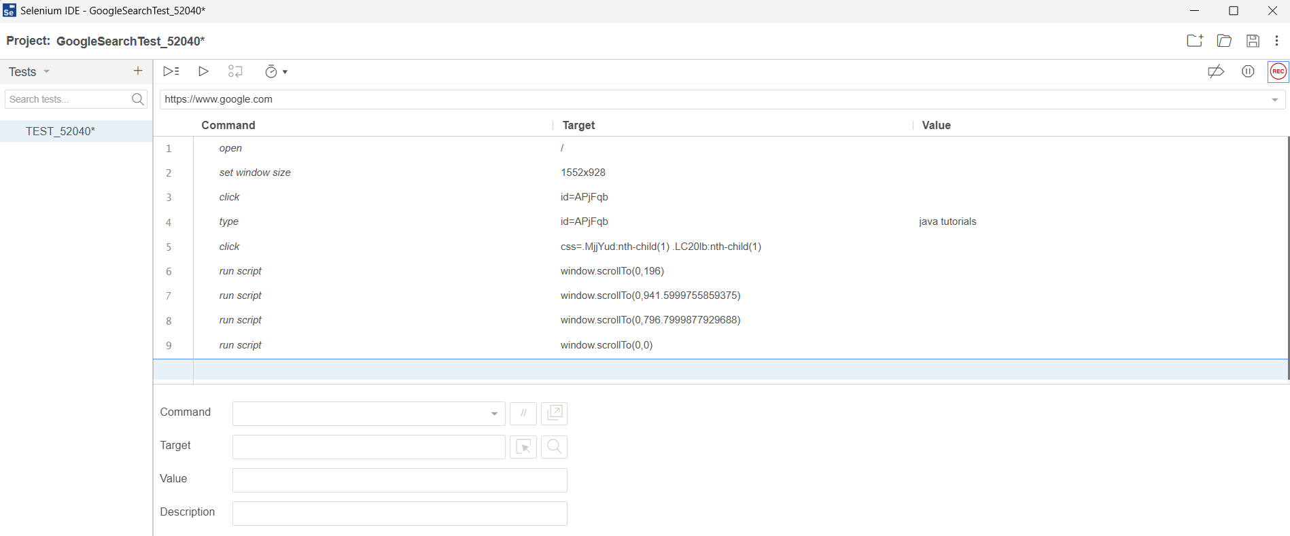

Step 3: The project and test name (e.g., GoogleSearchTest 52040) are visible.
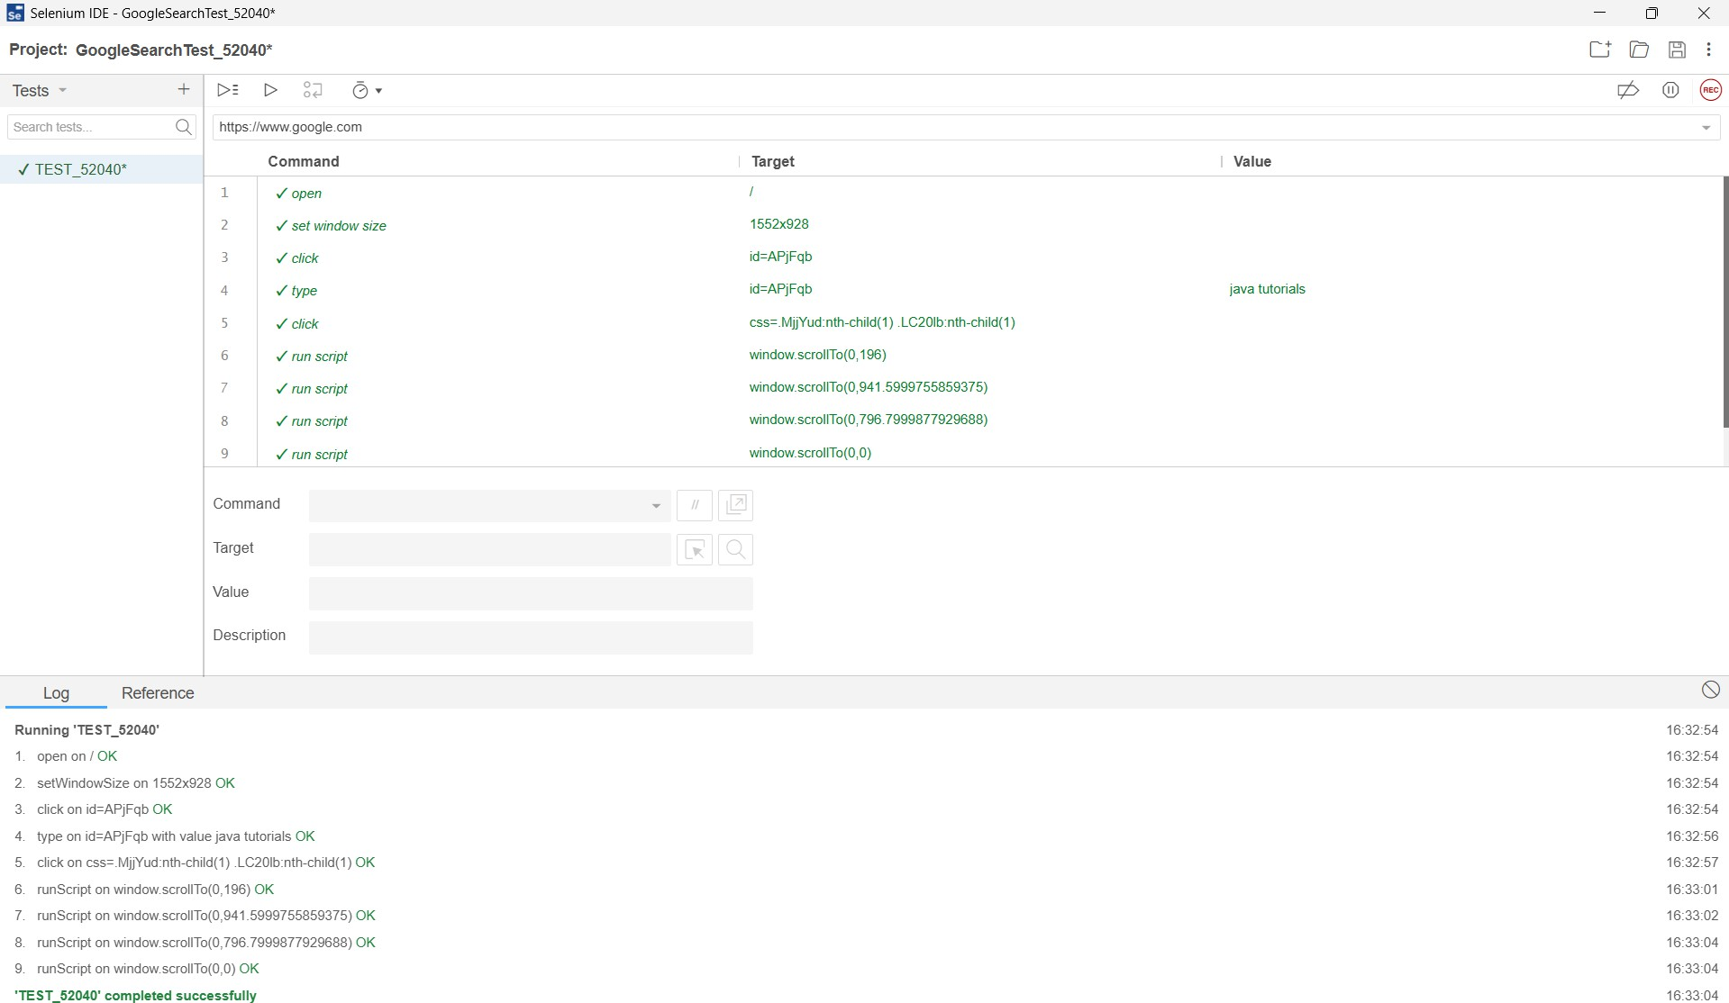

Test Results:
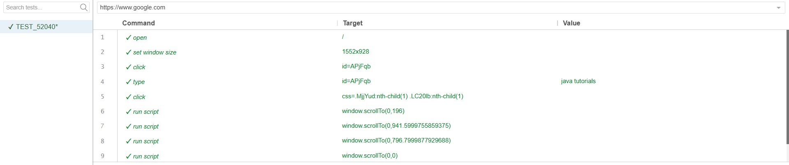

Logs :
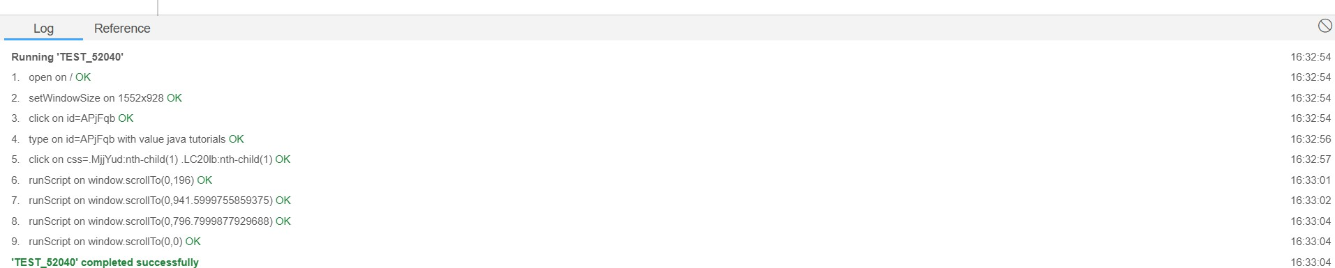

PRACTICAL SUBMISSION RECORD- A.Y. 2025-26

Class: SYMCA Div.: B  Semester: III | Course Code: MCA10602  Course Name: Laboratory Practice III |  | Batch: S2
Name: Ajit Bajarang Mali |  | Roll No: 52140
CO No: CO607.2 |  | Assignment No: 04

Title: Automate Gmail login flow using Selenium Web Driver.

Code:

Main.py:
from selenium import webdriver
from selenium.webdriver.common.by import By
from selenium.webdriver.support.ui import WebDriverWait
from selenium.webdriver.support import expected_conditions as EC from dotenv import load_dotenv
import os

# Load environment variables load_dotenv()
EMAIL = os.getenv("EMAIL")
PASSWORD = os.getenv("PASSWORD") # App Password recommended

if not EMAIL or not PASSWORD:
raise ValueError("EMAIL and PASSWORD must be set in the .env file")

# Initialize Chrome
options = webdriver.ChromeOptions()
# options.add_argument("--headless") # Uncomment for headless mode driver = webdriver.Chrome(options=options) driver.maximize_window()
wait = WebDriverWait(driver, 20) try:
# Open Gmail login page
driver.get("https://mail.google.com/")

# Step 1: Enter email
email_input = wait.until(EC.presence_of_element_located((By.ID, "identifierId"))) email_input.send_keys(EMAIL)
driver.find_element(By.ID, "identifierNext").click()
# Step 2: Wait for password field and enter password
password_input = wait.until(EC.presence_of_element_located((By.NAME, "password"))) password_input.send_keys(PASSWORD)
driver.find_element(By.ID, "passwordNext").click()

# Step 3: Wait for inbox to load (Compose button visible) wait.until(EC.presence_of_element_located((By.XPATH, "//div[text()='Compose']")))
driver.save_screenshot("gmail_inbox.png") print("Screenshot saved as gmail_inbox.png")
input("Press Enter to close the browser...")

except Exception as e: print("ERROR during login:", e)
input("Press Enter to close the browser...") finally:
driver.quit()

Output:
- Opens login page and automatically enter you email in it:

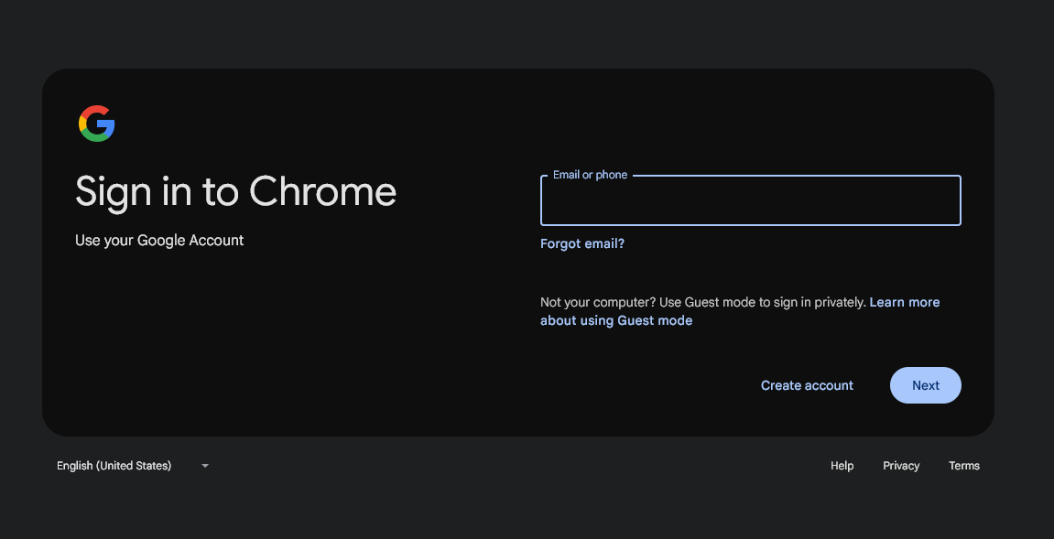
- Manually user will enter Password and click on next:
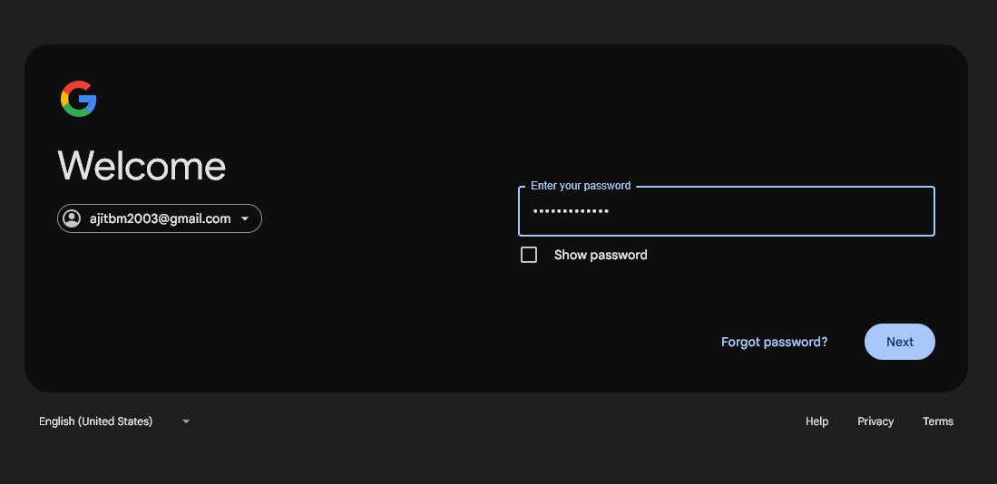
- Login Successful:
- Opens gmail in new Tab:
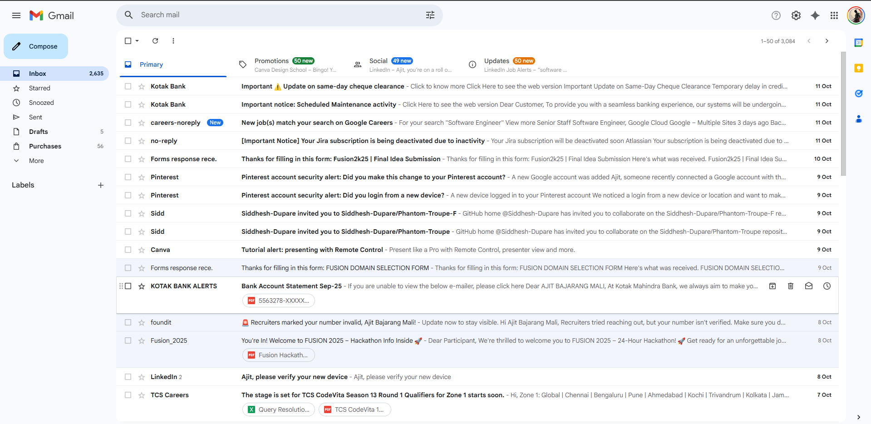
- To close tab click enter on keyboard in terminal :
